Sample Word report on the following the steps for creating a simple website.

The files submitted were:

* .py files
  + Admin, apps, manage, models, urls, and views
* .html files
  + Base, index, topic, topics
* .doc file
  + Sansone.Robert.Assignment-10

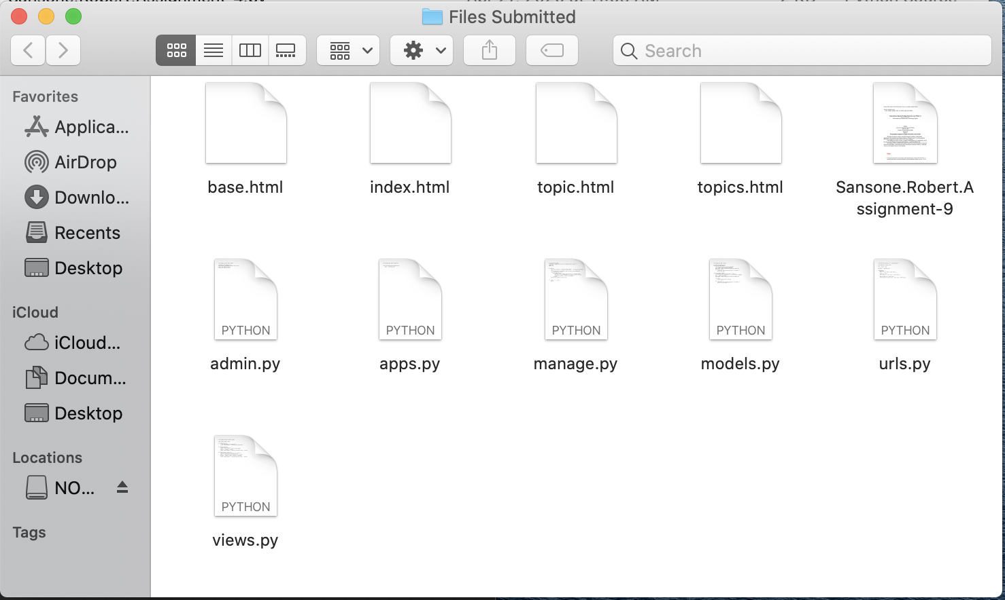

**Programming Assignment 10: Learning Log online journal system** for

Master of Science

Information and Communications Technology Program

Student

University of Denver University College

June 5, 2020

Faculty: Dr. Steven Russell, PhD

Director: Michael Batty, PhD

Dean: Michael J. McGuire, MLS

**Programming Assignment 9: Display Stock Data on the Website**

This paper documents a step-by-step walk-through of building a simple Django application. The steps follow the blueprint outlined in ‘Python Lesson 9’ as well as practices described in Chapter 18 and 19 of *Python Crash Course* by Eric Matthes.

All included screen shots are from a Macintosh. Applications used in the shots were the Terminal and PyCharm CE.

The program itself uses Python and Django to read from an external database of topics and content and in a web page on the user’s local machine.

**Steps:**

* Create a new directory for the project called ‘learning_log,’ switch to that directory in a terminal, and create a virtual environment with the command: python3 -m venv 11_env

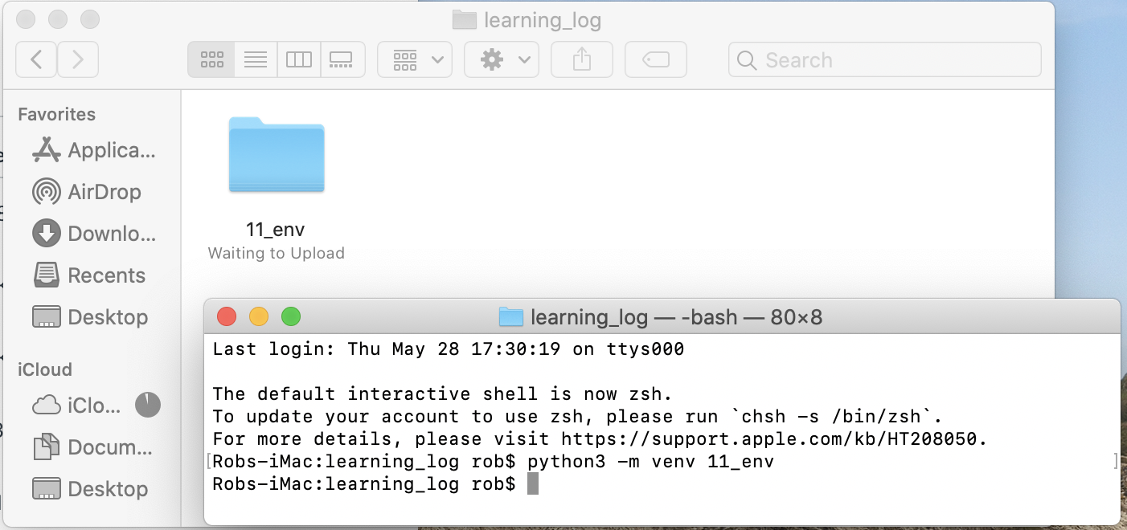

* Activate the learning_log virtual environment with the command: source 11_env\bin\activate

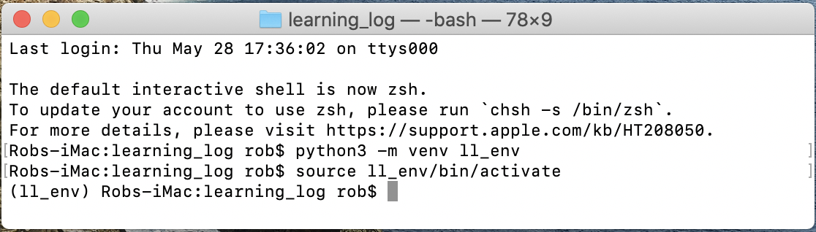

* Install Django in the learning_log virtual environment with the command: pip install Django

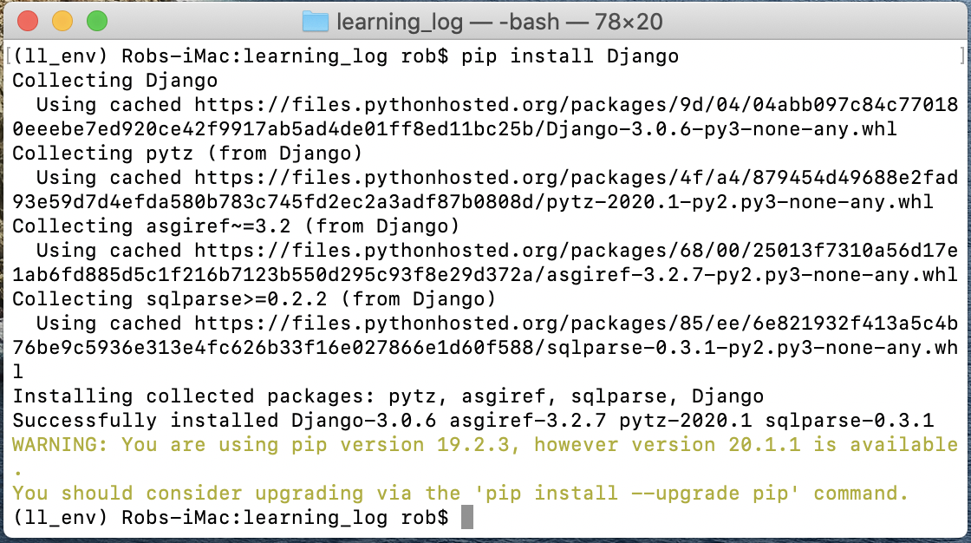

* Create the new learning_log project with the command: django-admin startproject learning_log .

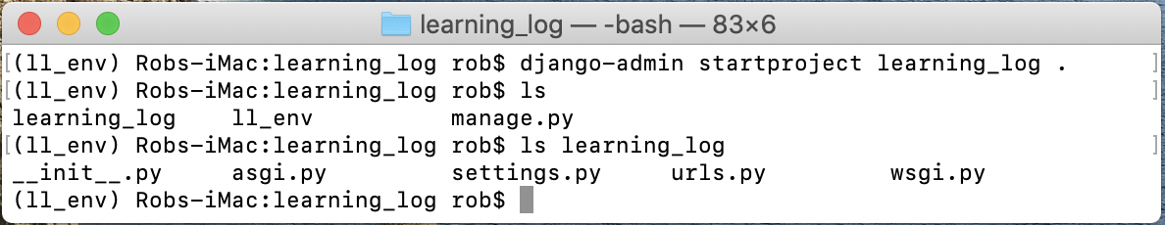

* Open learning_log folder to check that the new learning_log directory has been created, including the file manage.py:

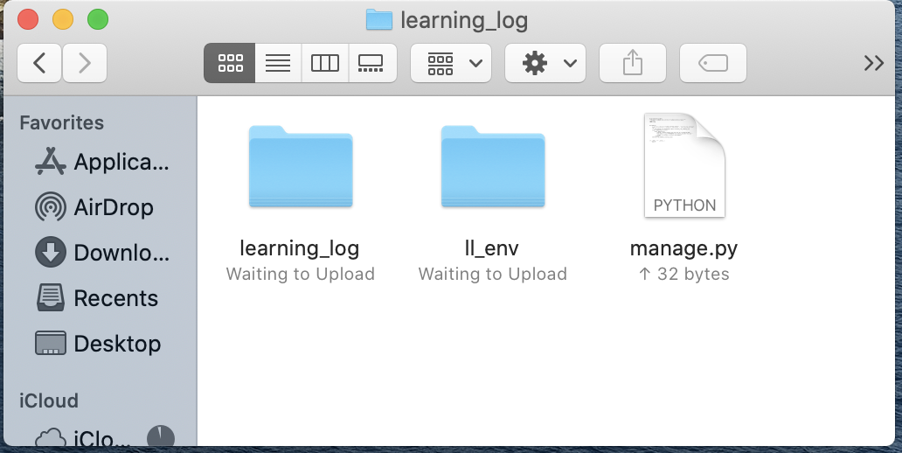

* Check inside the learning_log directory to make sure the settings.py, urls.py, and wsgi.py files were created.



* Creating the database with the command: python3 mange.py migrate

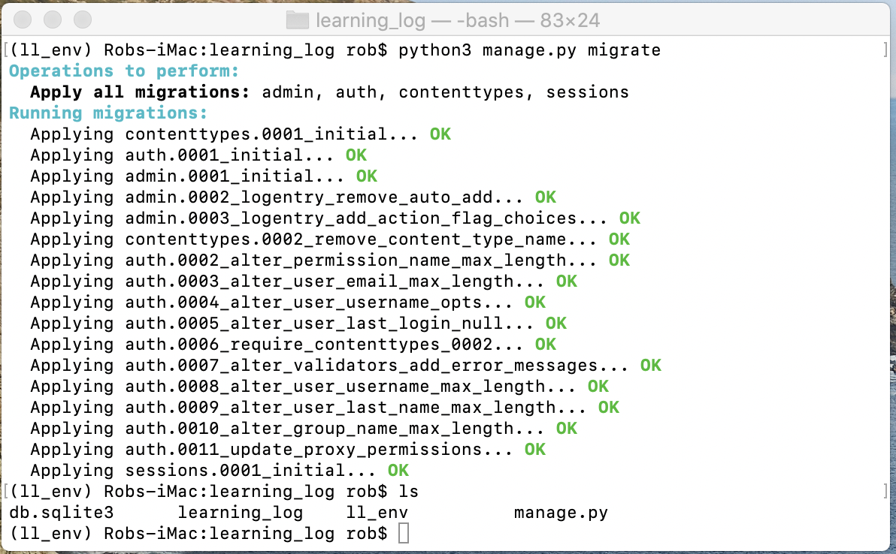

* Define the model in models.py.

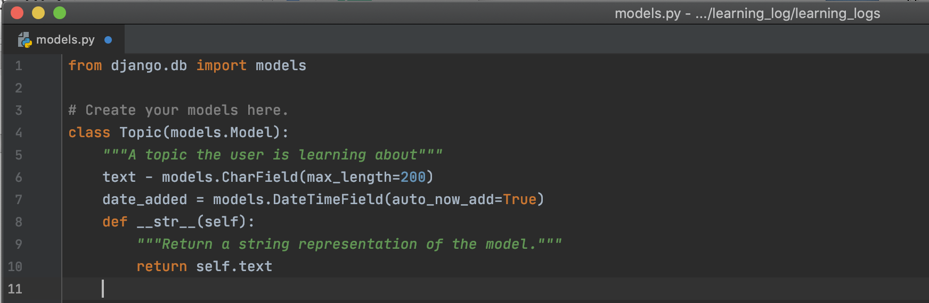

* Activate model in settings.py.

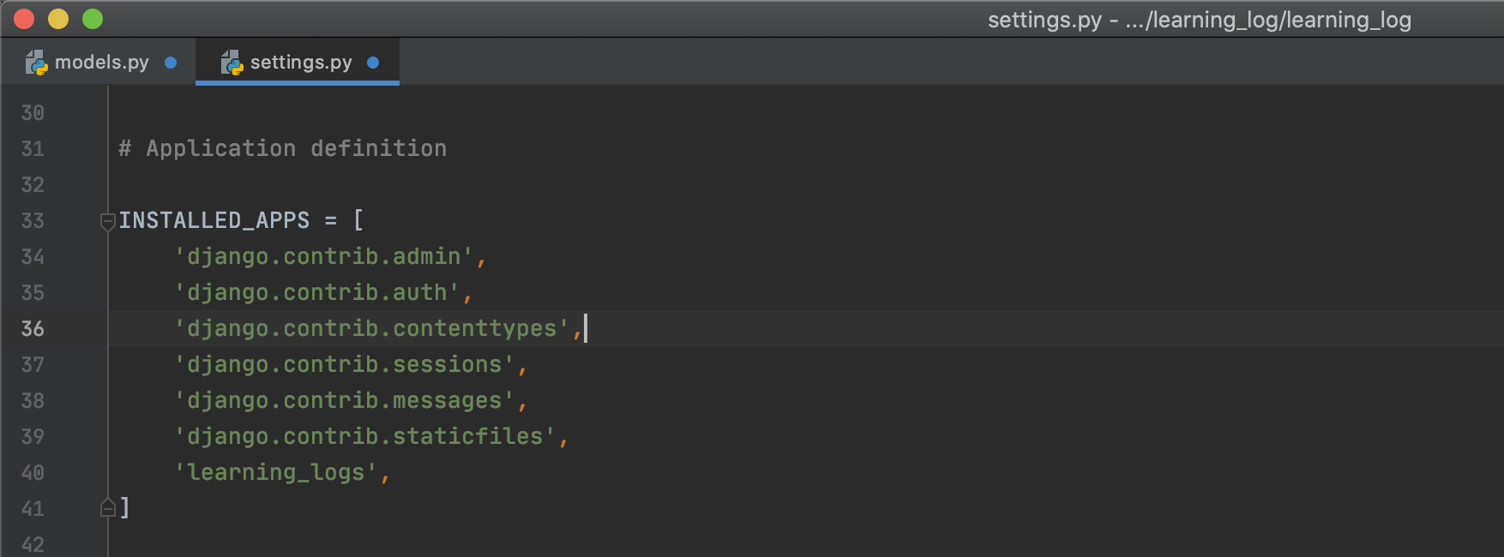

* Modify database so it can store information related to the model Topic using the command: python3 manage.py makemigrations learning_logs

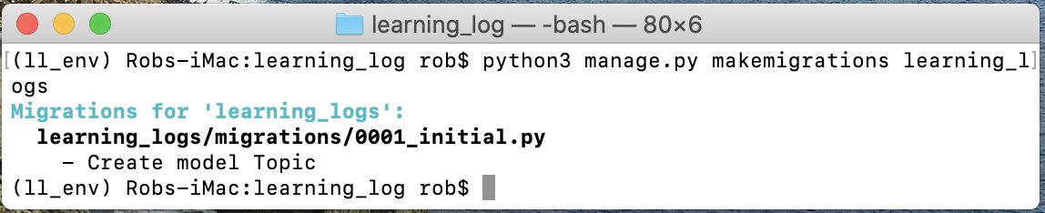

* Modify database with command: python3 manage.py migrate

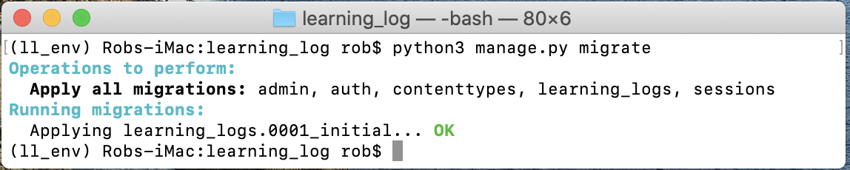

* Setting up a superuser using the command: python3 manage.py createsuperuser

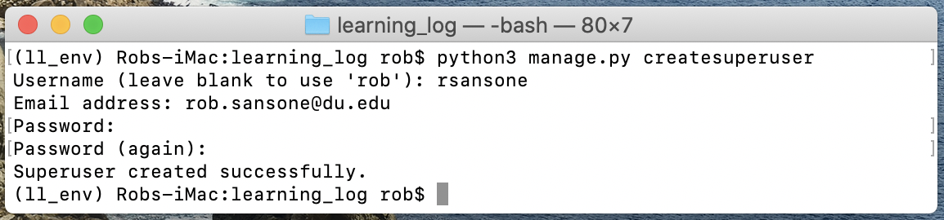

* Register a model with the admin site:

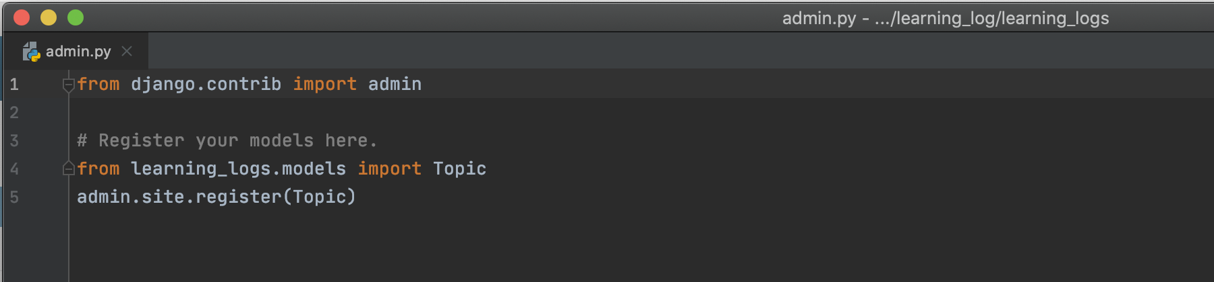

* Check admin site.

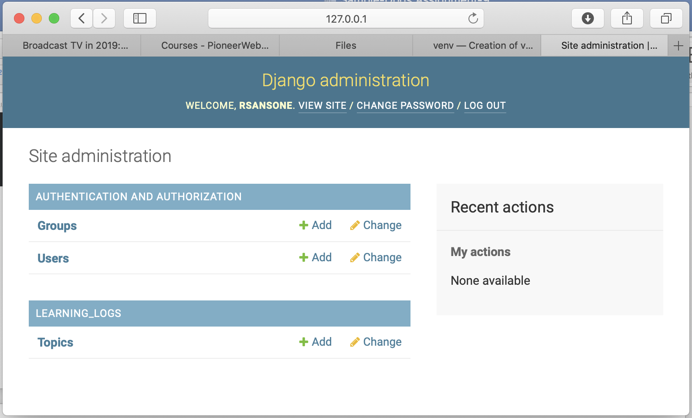

Check to see if Add functionality works.

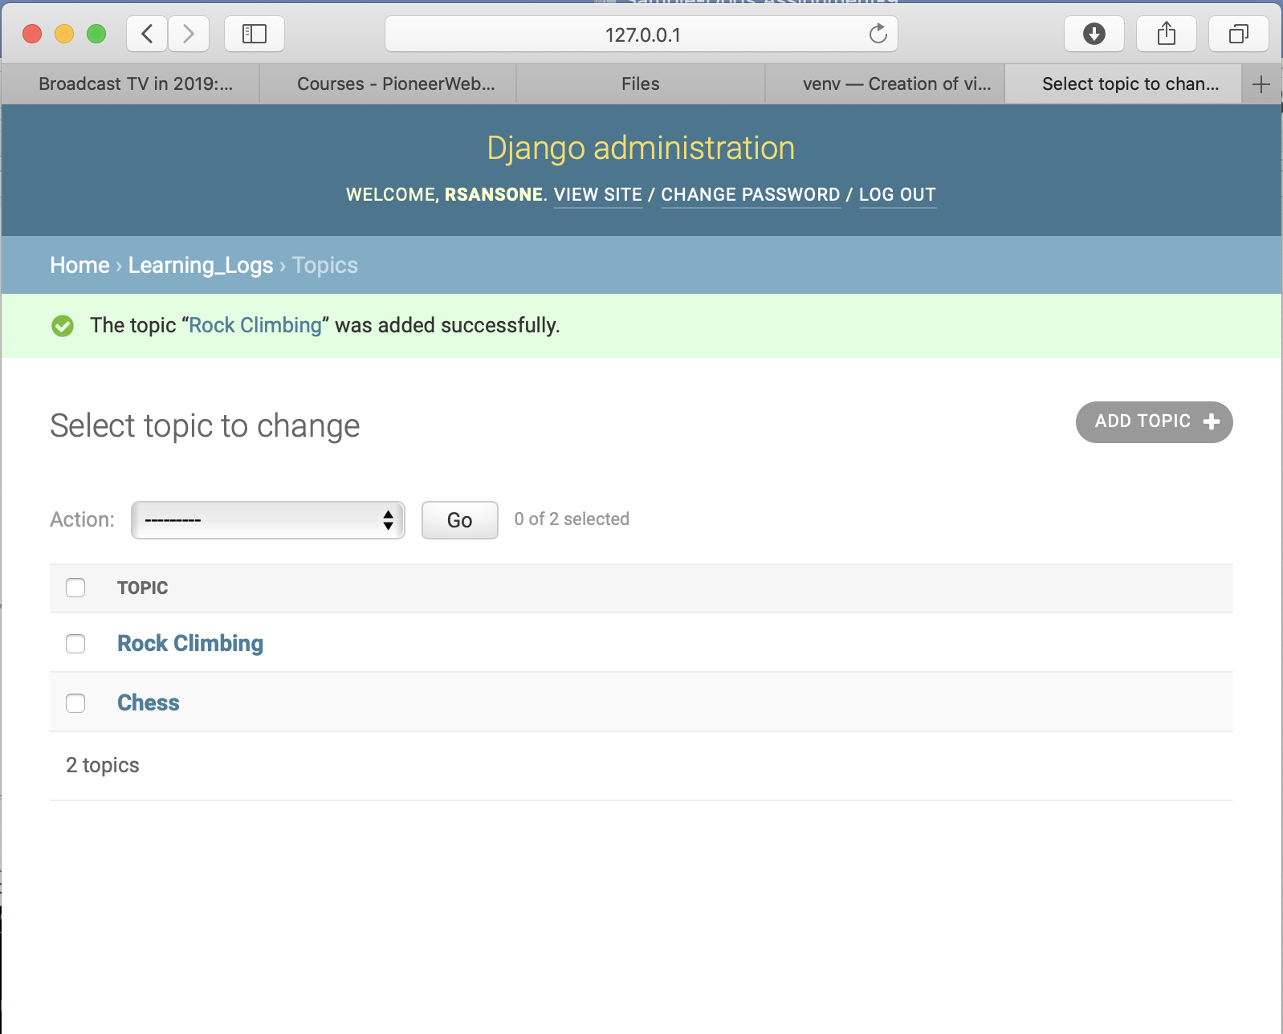

* Define the Entry Model by adding Entry class to models.py

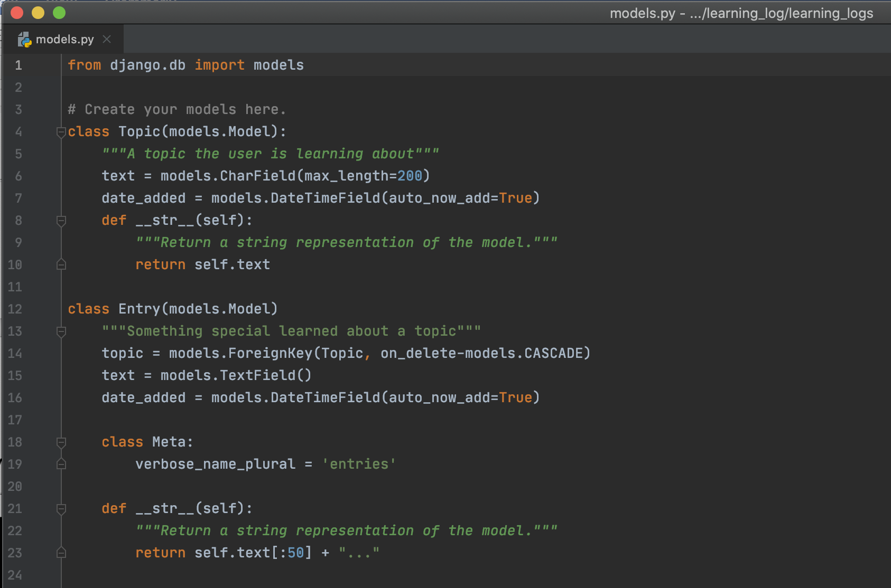

* Migrate the database again to add new Entry model.

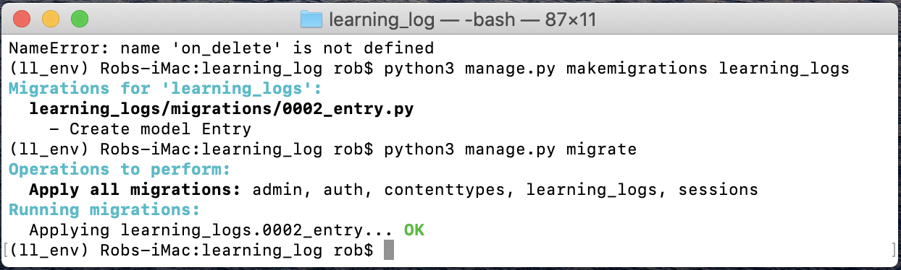

* Register Entry with the admin site through admin.py.

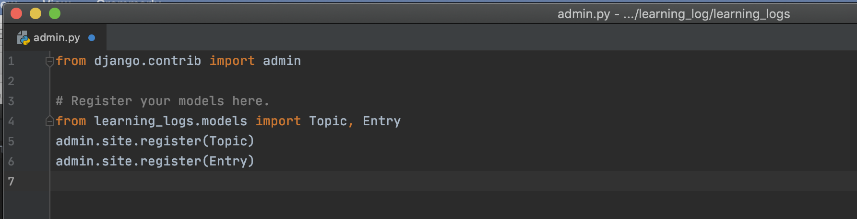

* Test the Entry function on the site.

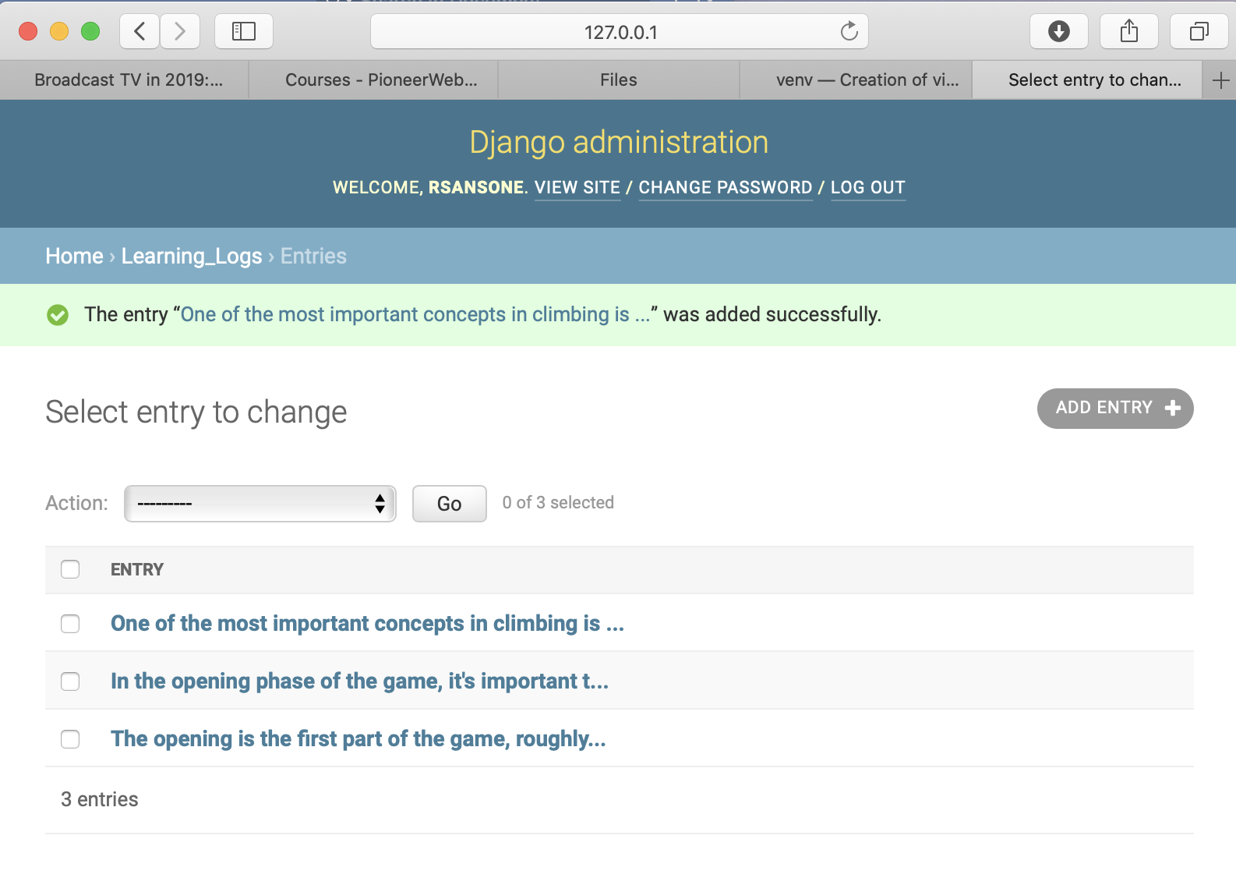

***Making pages: The learning log home page.***

* Mapping a URL in urls.py for learning_log.

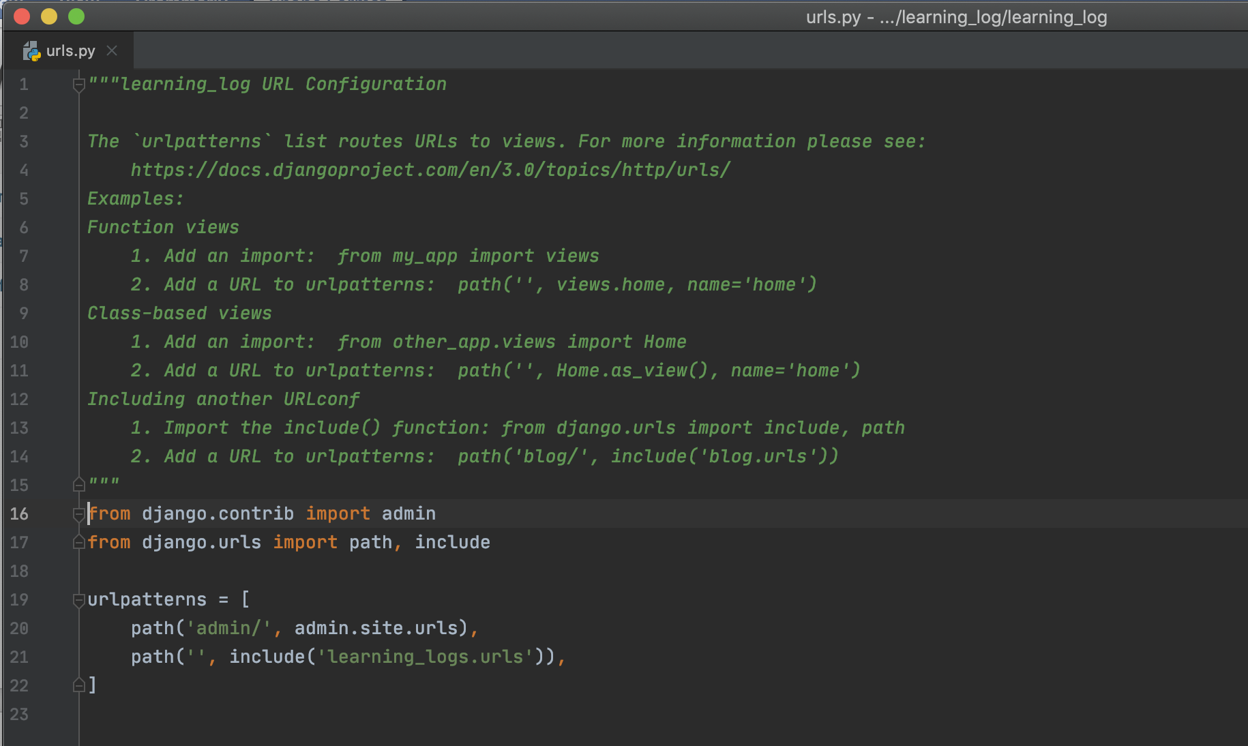

* Adding urls.py file to learning_logs app.

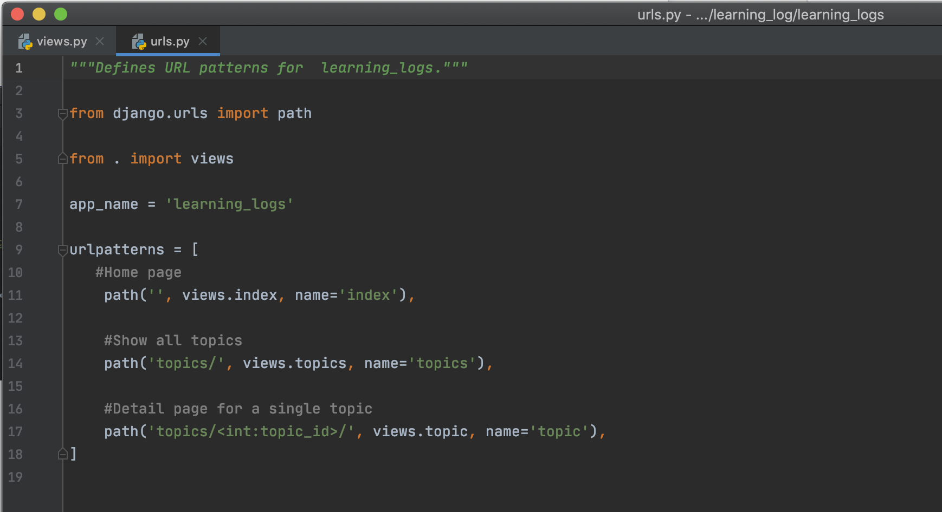

* Create views in views.py.

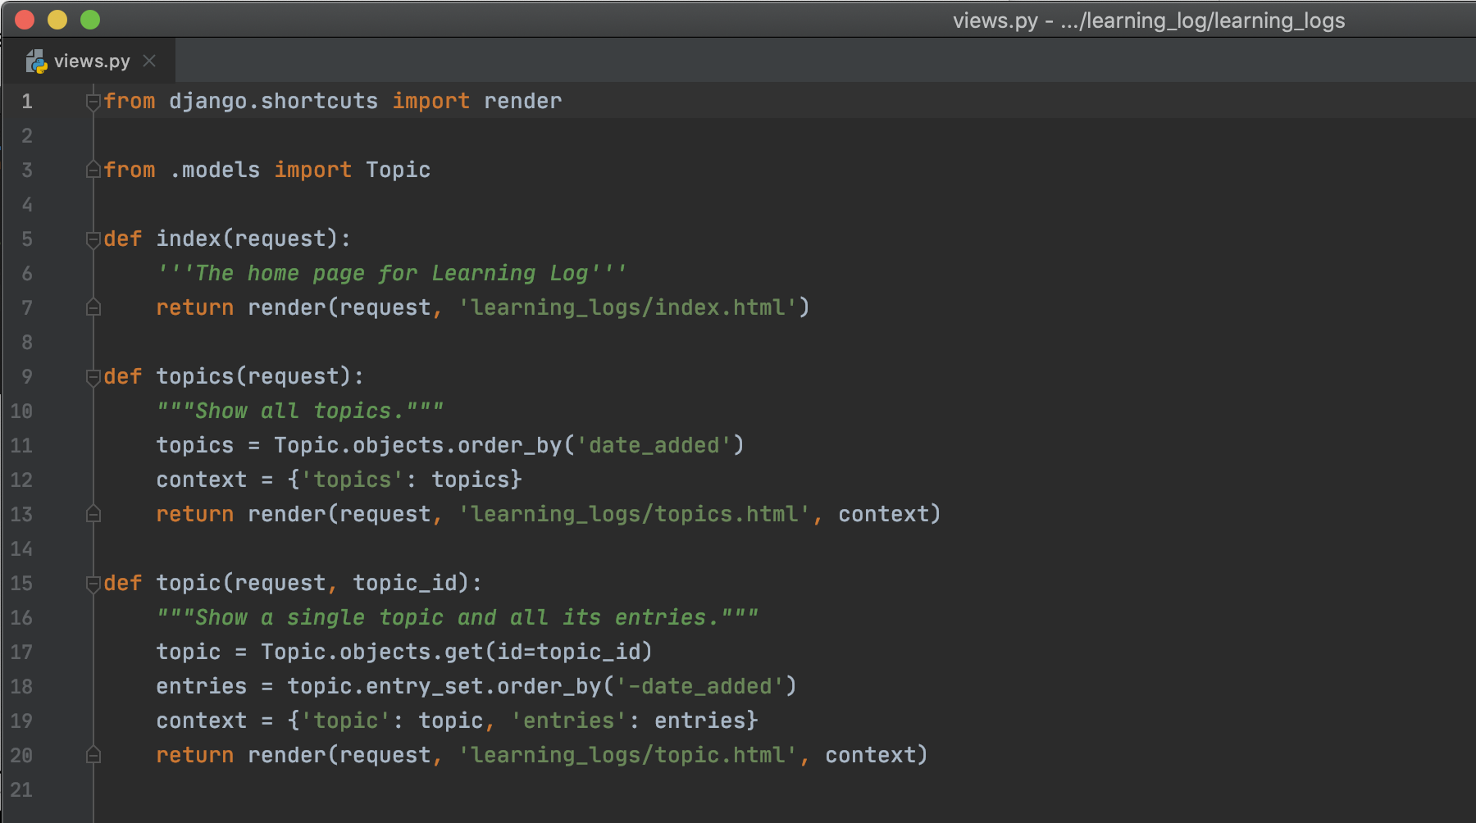

* Write templates for the view.

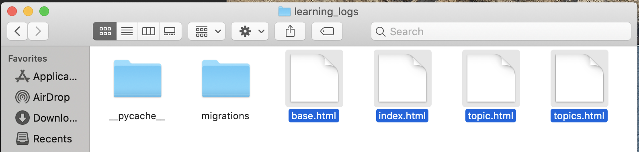

* View home page.

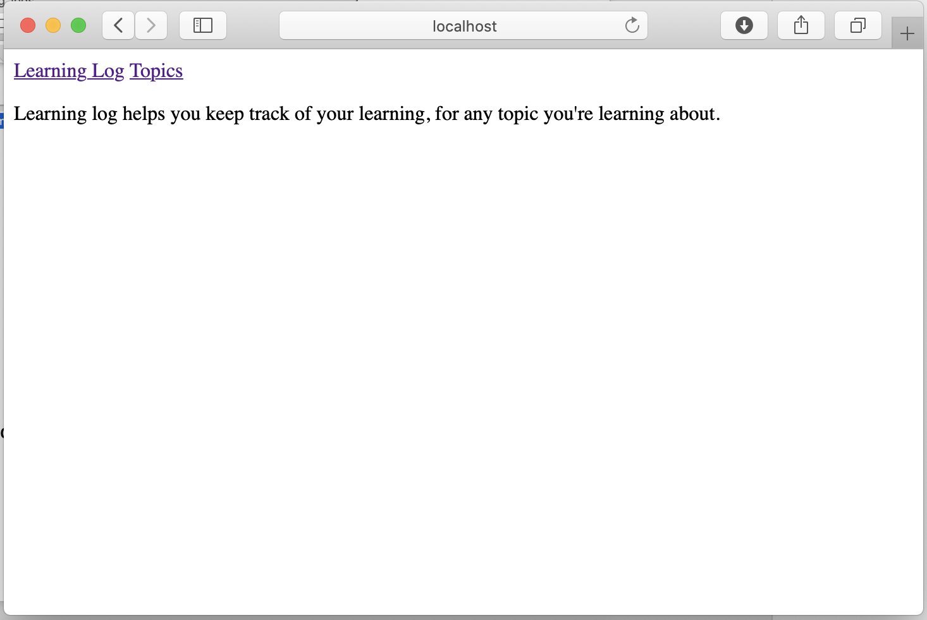

* View Topics page

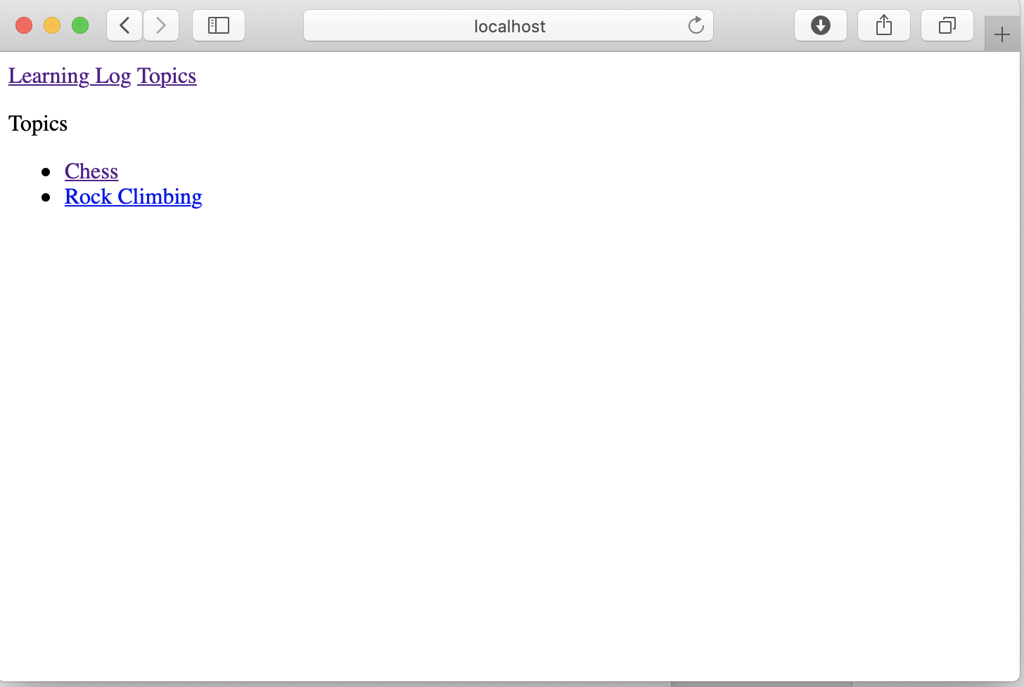

* View individual topic page.

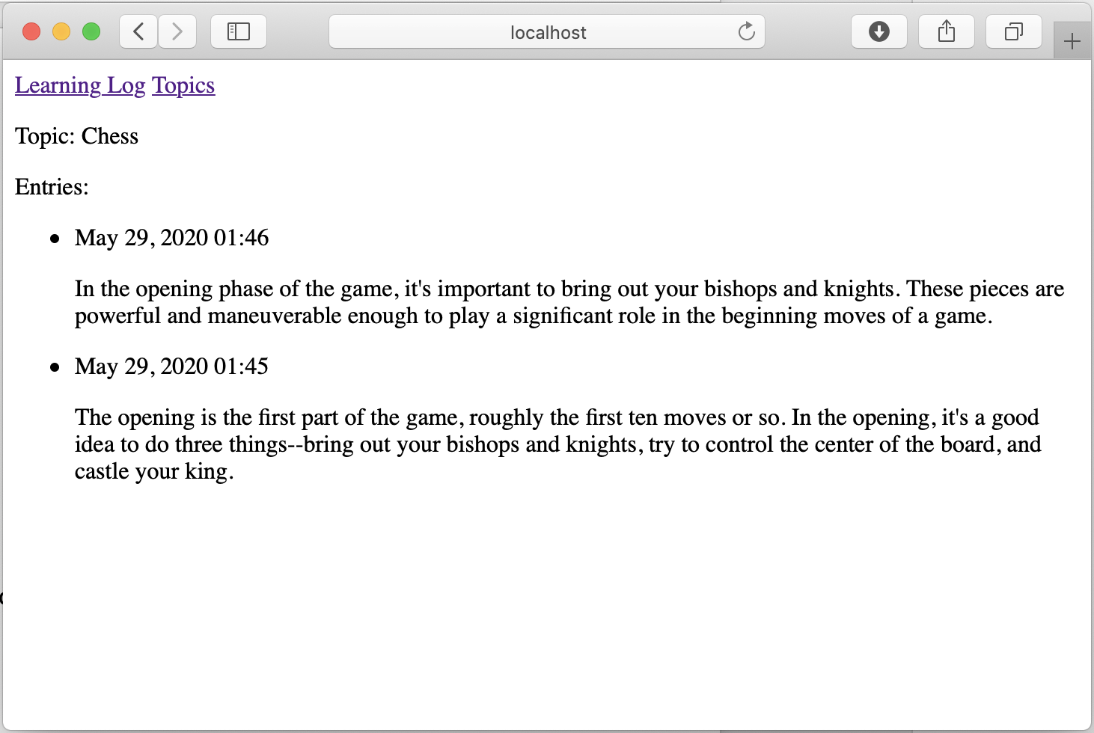

Allow users to add data

* Create a form by creating a forms.py file

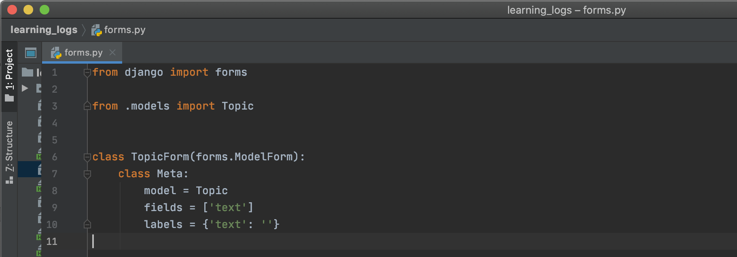

* Add new_topic URL

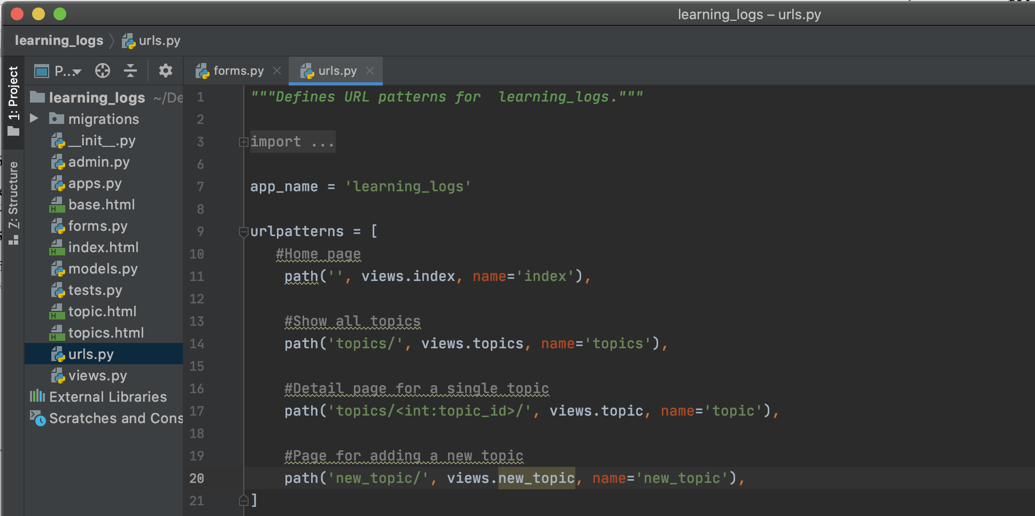

* Add new_topic View Function

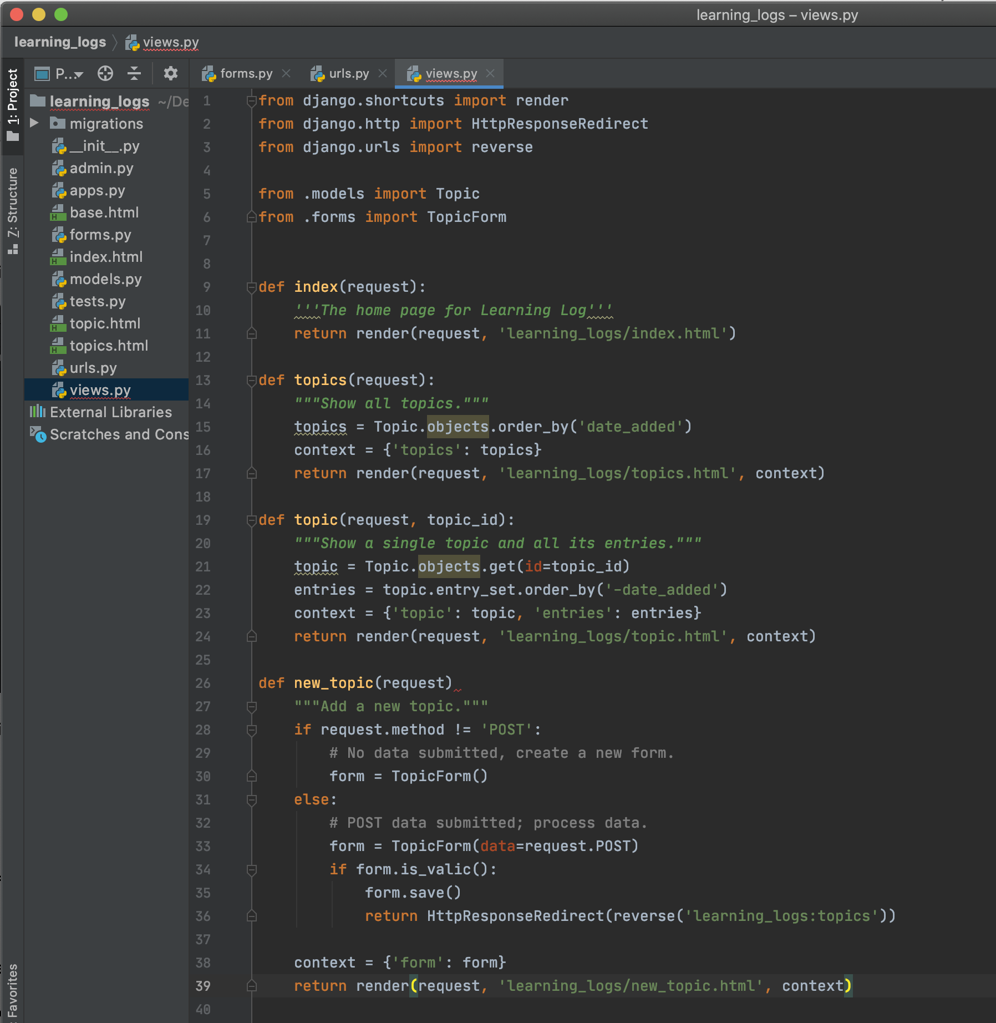

* Create a new_topic template

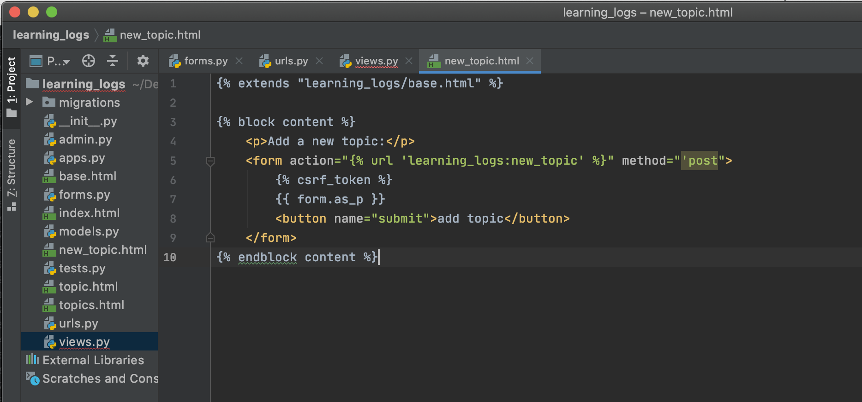

* Create link to new_topic page

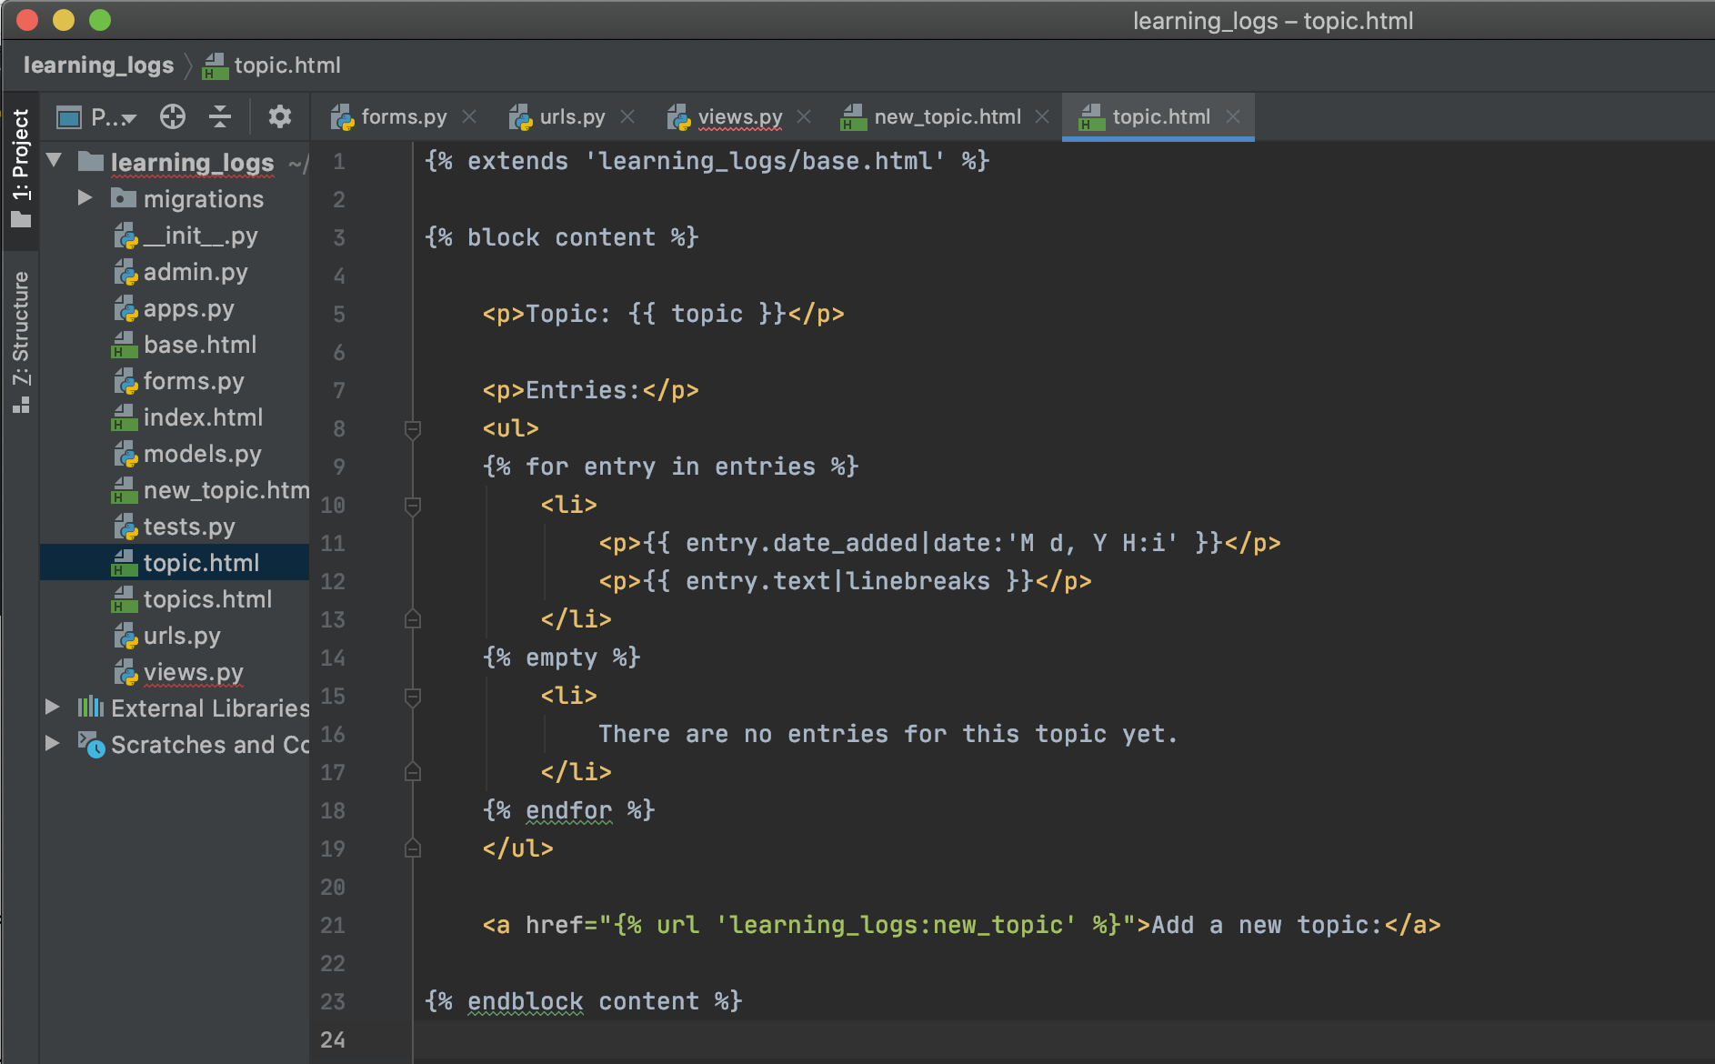

* Test new_topic page

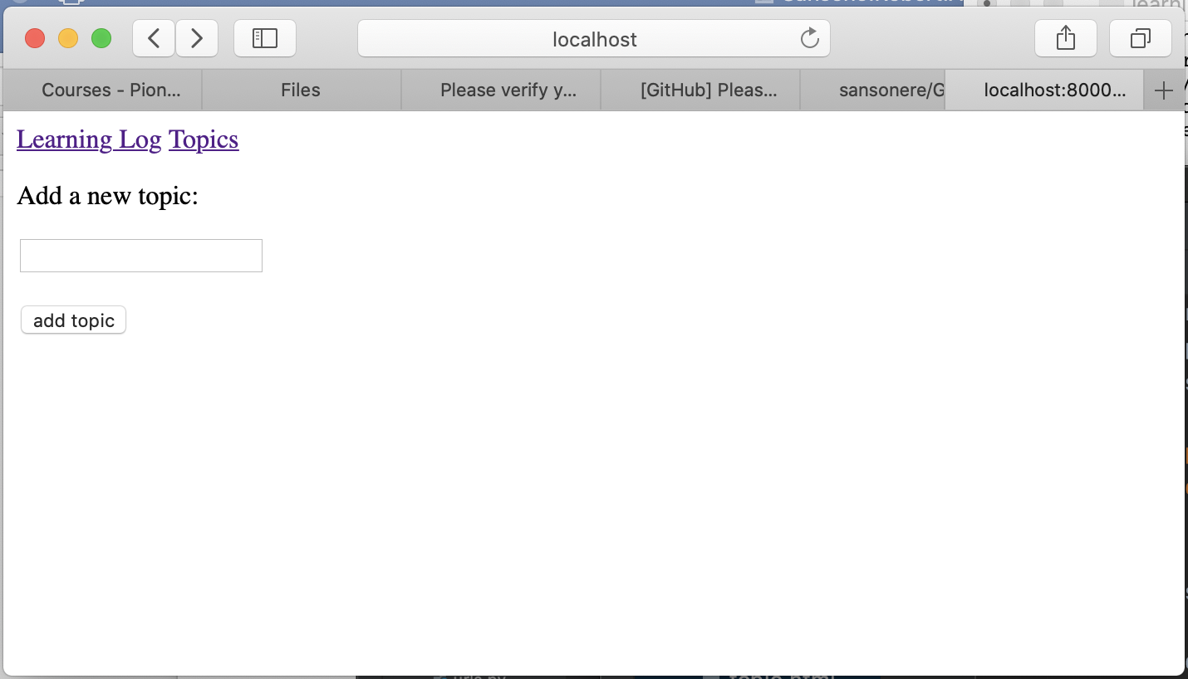

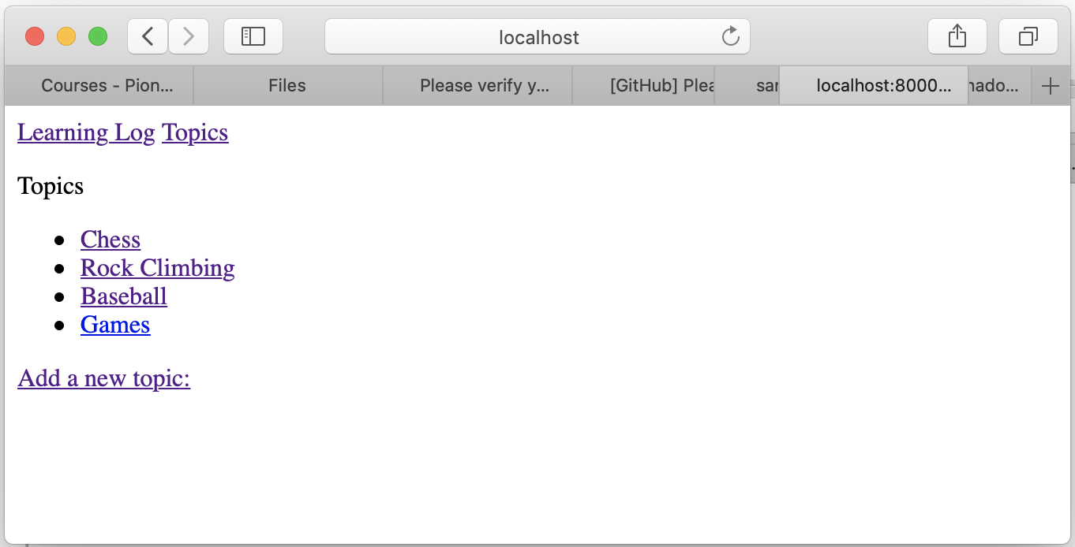

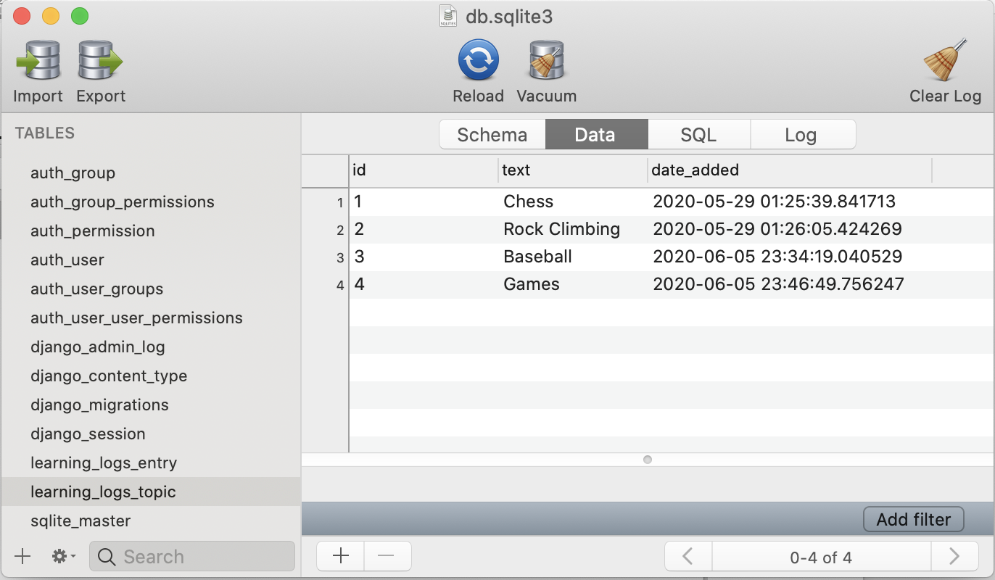

* Add new entry form

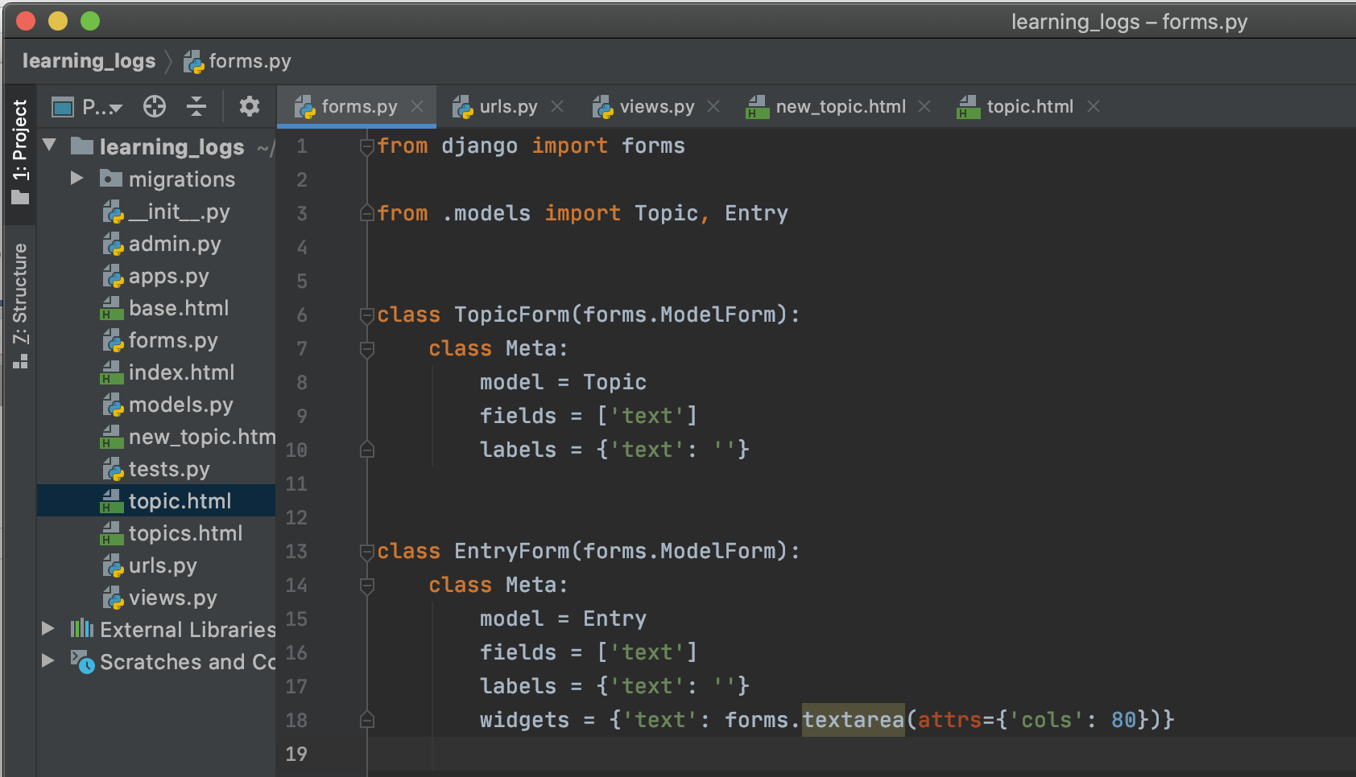

* Create new_entry URL

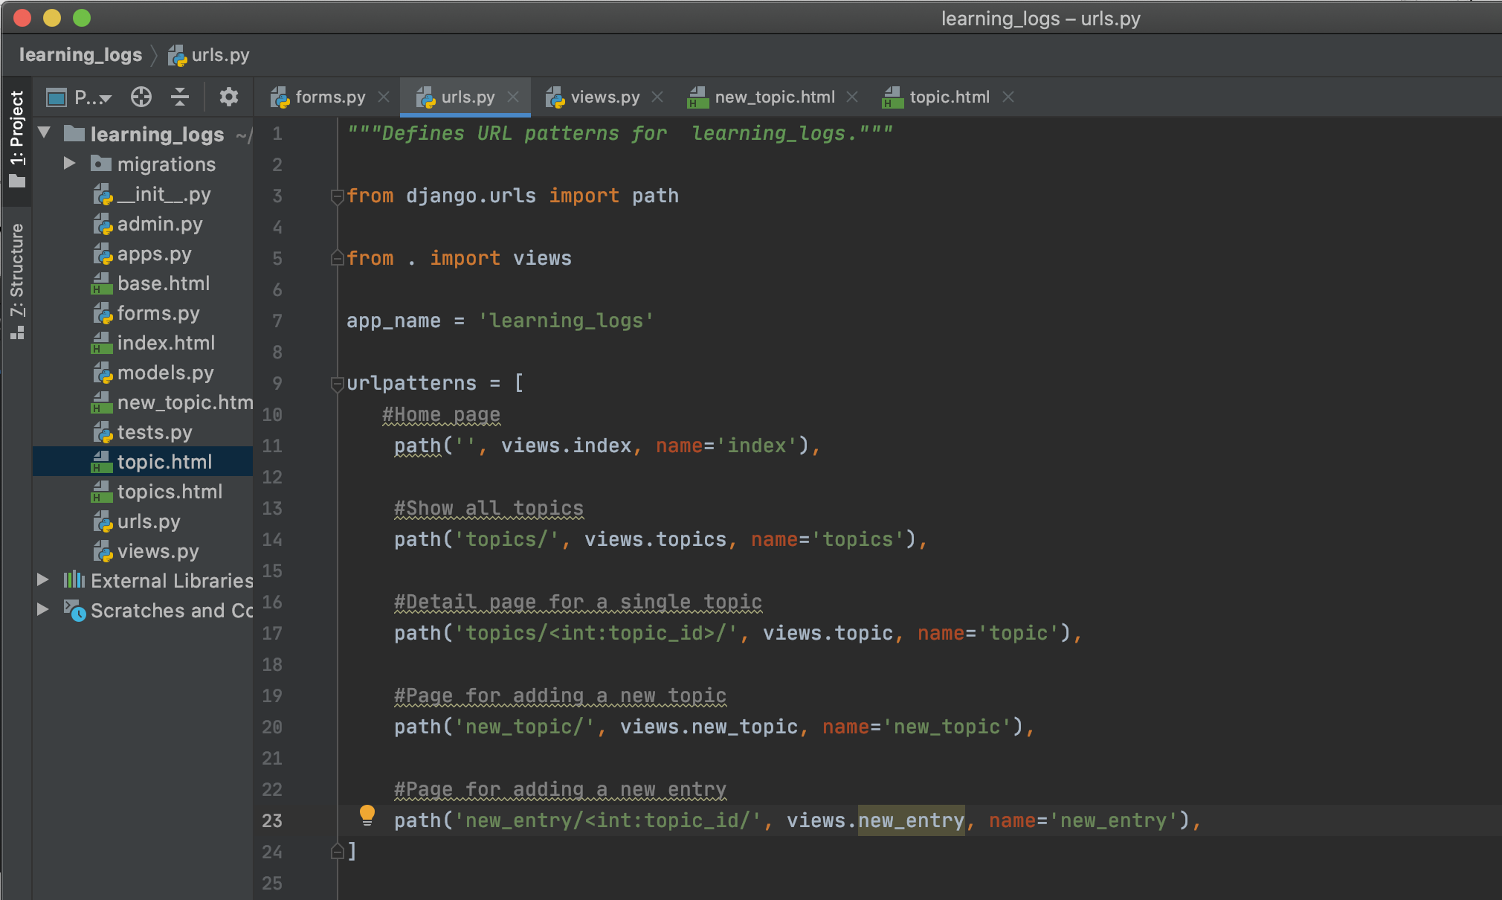

* Create new_entry View function

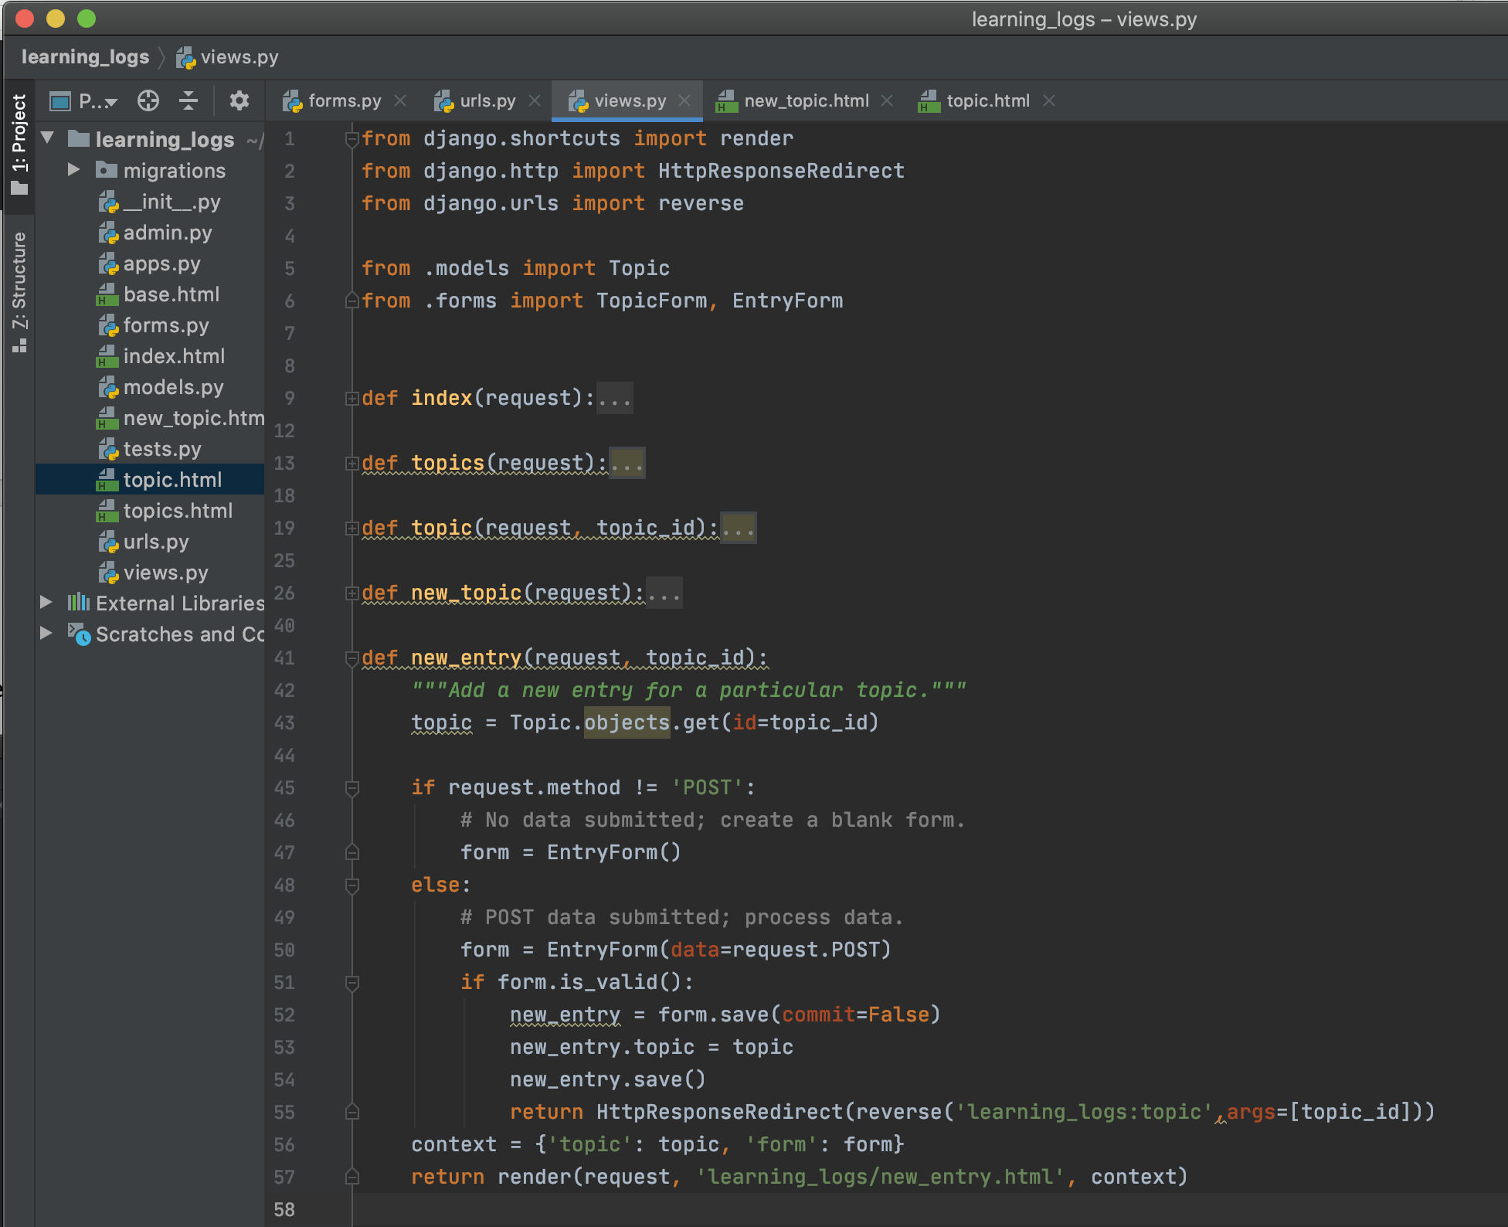

* Create template for new entry

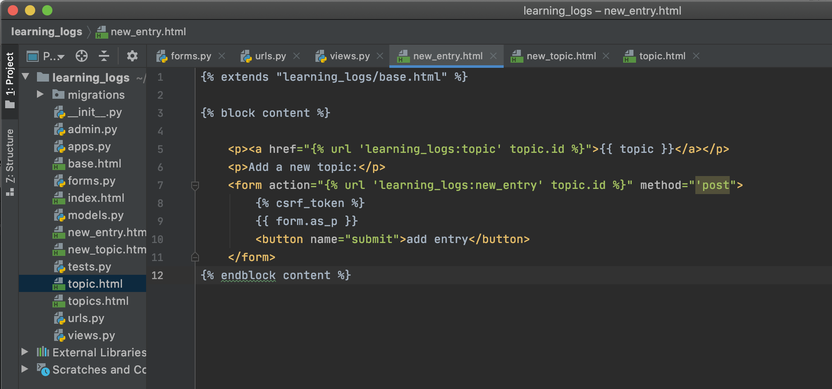

* Linking to the new_entry Page

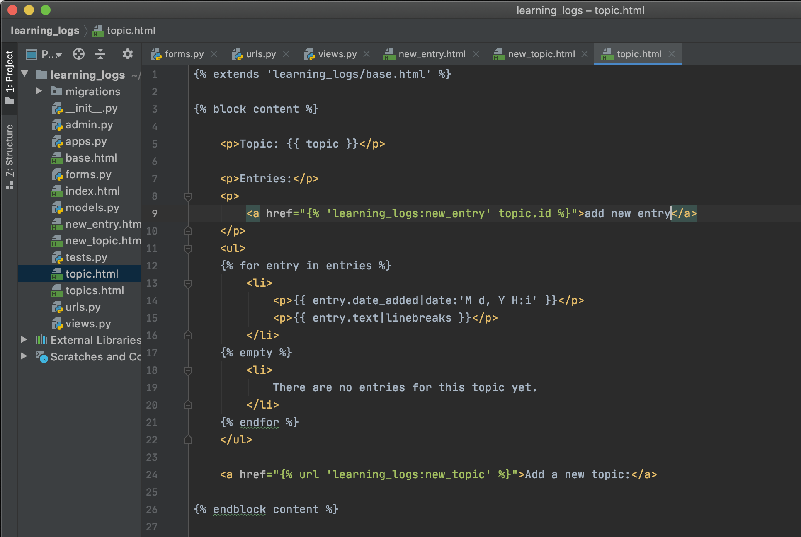

* Test new entry page

Failure

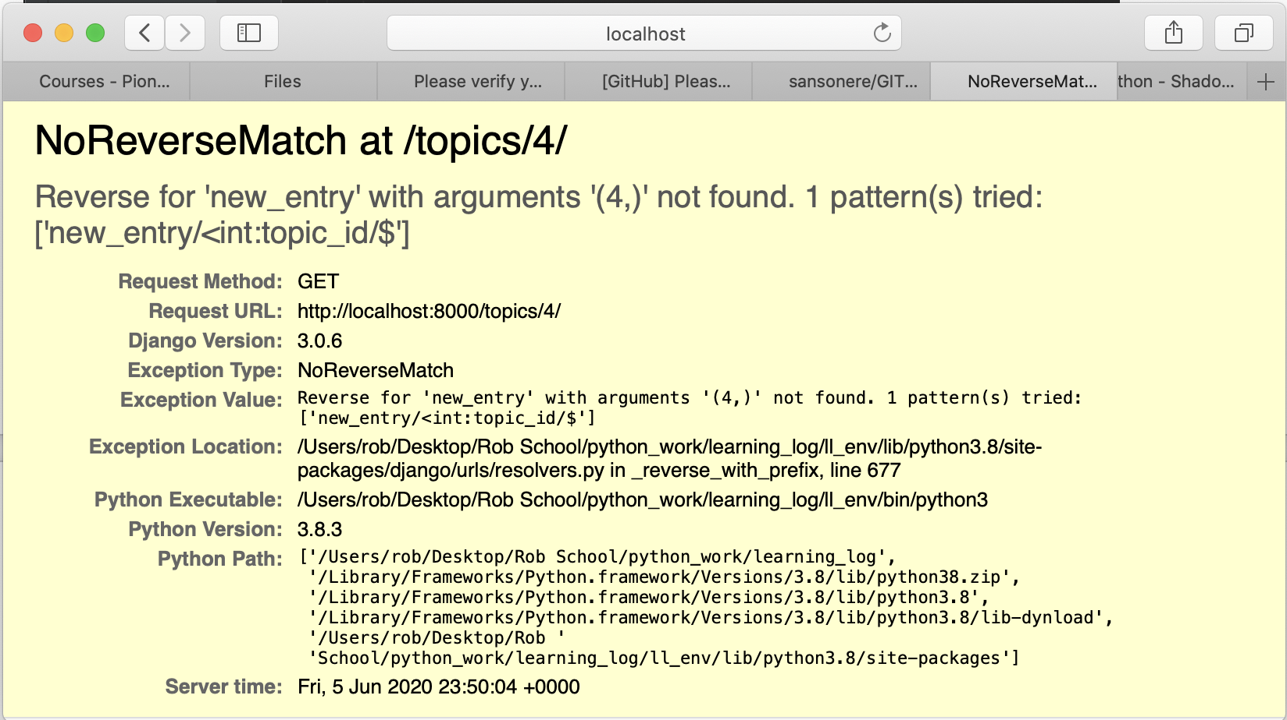

-===================================

Conclusion – Notes

I’m not sure what happened. I followed the instruction to the letter. It has something to do with the reverse command in my views.py file I think. The new topic functionality worked perfectly though.

-======================================